**RESUME**

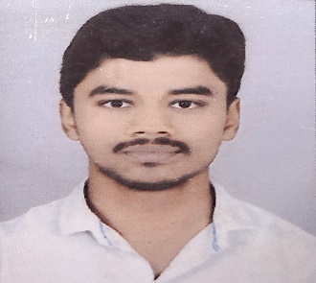

**NAME :- Shailesh Pramod Raut**

**EMAIL ID :-** [**shaileshraut415@gmail.com**](mailto:shaileshraut415@gmail.com)

+9197679 99398

**OBJECTIVE :-**

Looking to works as a mechanical engineer with experience in computer and manufacturing to help the organization progress.

**EDUCATIONAL QUALIFICATION :-**

* Passed out B.E (mech) from Savitribai Phule Pune University,in 2021.

Marks :-

SGPA :-9.09

CGPA :- 6.44

Higher Second Class

* Passed out 12th from Dayanand Science College Latur.

Higher Second class

* Passed Out 10th from Janata Vidya Mandir Murud.

Marks :-

PERCENTAGE : - 87.80

First Class

**COMPUTER SKILLS :-**

* MS Excel.
* MS Word.
* MS Power Point.

**IT SKILLS :-**

* C,Java,Programming Language .

**STRENGTH & HOBBIES :-**

* Hard and Smart working.
* Good Leasner & Speaker.
* Honest & Punctual.
* Drawing, cricket,Reading Books , Dancing.

**PROJECT :-**

* Optimization on injection moulding machine.

**INTERNSHIP :-**

* Kalashree Engineering working as a Quality engineer.

I hereby declare that the information provided above is true

DATE SIGNATURE